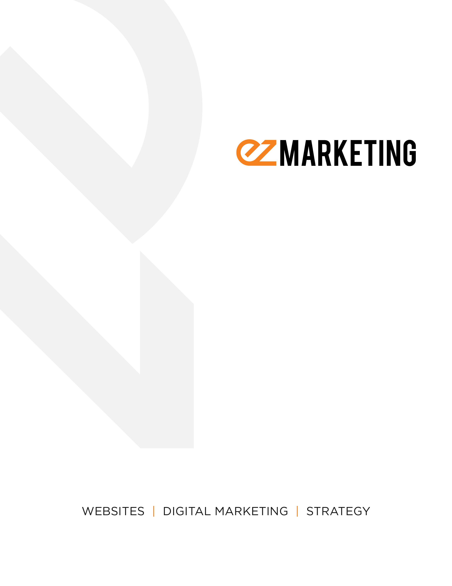

Marketing Plan Template

Marketing PLan Template

Why bother with a marketing plan?

While busy marketers are often tempted to jump right into doing marketing, taking the time to write down a strategy is critical. Marketers who document their strategy are 538% more likely to report success than those who don’t.

A written marketing strategy helps you identify your ideal customers, define your unique strengths, and craft the right message for the right people at the right time. It gives your entire business direction, so you know what marketing efforts to focus on – which puts you in control of your marketing.

The EZ Marketing Process
Great marketing doesn’t happen by accident. We’ve developed a six-step process to help businesses research and plan their marketing, so they have a much greater chance of success.
- Deep Discovery - Study your business universe to discover your strengths, weaknesses, competitors, and current customers
- Ideation - Create a brand profile including your ideal customer, unique selling proposition, and goals
- Strategy - Determine your overall approach to achieving your goals and delivering the right message to your target audience
- Tactics - Implement the actual tools and techniques to execute your strategy
- Analysis - Track key metrics – based on your objectives – so you know what’s working and what’s not
- Adaptation: Regularly evaluate your efforts and make improvements to your strategy

About This Template
This document is meant as a guide for the type of information you’ll want to include in your marketing plan. You may have more or less detail, depending on your business. The questions in each section should help get your brainstorming process started.

Executive Summary

(In a page or less, summarize this marketing plan. Start with your company’s mission/vision or any other company values that give context for your marketing plan. Include a brief overview of your goals and how you plan to achieve them. Write this section last.)

Mission/Vision
- What do you do?
- Who do you do it for?
- Why do you do what you do? What is your business’s purpose for being?
- How do you add value, or help solve problems for your customers?

Summary Information
- What are your overall marketing goals?
- What are you trying to communicate to your audience?
- What is your USP?
- How are you going to achieve your goals?
- What is your definition of success?

Market Overview

(In order to figure out where you want to go, you first need to define where you are currently. Describe your current business universe, including your own strengths/weaknesses and those of your competitors.)

Current Situation
- What are your business’s core capabilities/competencies?
- What is the state of your industry/marketplace?
- Who are your current customers?
- Is there any relevant market research you want to include? Customer surveys & feedback, industry reports, analytics data, etc.
- What kinds of marketing are you already doing?
- What’s working? What would you change? Are you proud of your marketing?

SWOT Analysis
- Strengths
  - What are you great at?
  - What do your clients say they love about you?
  - What advantages do you have?
- Weaknesses
  - What needs improvement?
  - What do your clients complain about?
  - Why don’t people choose to buy from you?
- Opportunities
  - What’s going on in the market?
  - Are there changing trends/technologies you can take advantage of?
  - Are there underserved areas of the marketplace?
  - Are there new markets you can expand to?
- Threats
  - What obstacles do you face?
  - What is your competition doing?
  - How’s your cash flow?
  - Do you have strong business or marketing plans in place?

Competitors
  - Who are your top competitors?
  - What are their core competencies? How do they differ from yours?
  - What are their strengths/weaknesses?
  - What is their marketing mix? Where and how are they promoting themselves?

GoALS

(Determine your overall goals for your marketing plan. These may be financial goals, such as increasing sales, or non-financial goals like building brand awareness. As you refine your strategy, come back to these goals and layer in more details to make them S.M.A.R.T. Use the questions below to help add detail to each of your goals)

SMART Goal
- Specific
  - What exactly are you trying to achieve?
  - How will you reach this goal?
  - Who is involved?
  - Where will this happen?
- Measurable
  - How will you know when you have achieved this goal??
  - What metrics do you need to track?
  - How much? How many?
- Attainable
  - Is this goal realistic?
  - Do you have the tools, skillset, and/or resources to accomplish it?
- Relevant
  - Why is this goal important?
  - How will this goal support your overall business objectives?
- Timely
  - When will you accomplish this goal?
  - What milestones do you need to achieve along the way?
  - How high a priority is this goal?

Ideal Customer Profile

(Define your target market and develop buyer personas to dig deeper into who your customers are, what they need, and what motivates them. You may need multiple buyer personas to address the different types of people within your target market)

Target Market
- Who are your best customers? Why?
- What kinds of customers do you dislike working with? Why?
- Typical demographics: Gender? Age range? Income?
- Do you target a specific size of business or industry niche?
- Where are your customers located? Do you have a specific geographic service area?

Buyer Personas
- What is their title/job function?
- What does their typical day look like?
- What is their background? (Relevant interests, experiences, hobbies, etc.)
- What do they want? What are their goals?
- What keeps them up at night?
- How can you help them solve their problems?
- What are the most important factors they consider when evaluating a product/service like yours?
- What information do they need in order to make a decision?
- How/when do they get their information?
- What sources do they trust?

Marketing MIx

(Describe the overall strategy you will use to reach your ideal customers and achieve your marketing goals. Then detail the specific tactics you will use to execute that strategy. Remember, your strategy should seek to solve problems for your customers and differentiate you from your competitors. Identify the 7 P’s of your marketing mix, including any variations in your tactics to promote different products)

Product
- What product(s) or service(s) are you selling?
- Why do your customers need it? How does it help them solve their problems?
- What are the features and benefits?
- How is this product/service different from your competitors?
- What calls to action, guarantees, or social proof are you including to get your customers to take action?

Price
- How much should you charge for this product/service?
- What is your total cost in order to sell this product/service? Is it profitable?
- What is your competitor’s pricing for this product/service?
- Are your customers getting a good perceived value for the price?

Place
- Where will you sell your product/service?
- What distribution channels are you using? A physical store? Online or e-commerce? Direct sales? Wholesalers?

Promotion
- How will you get your message in front of the right people at the right time?
- Which tools and tactics will you use? Website? Social media? Print? In-person events?
- Where does your target audience spend time?
- Will you advertise your business? If so, what digital or traditional methods will you use?
- Is your sales message compelling? Does it speak to your target audience?

People
- Who will execute your marketing strategy? What are their responsibilities?
- What skills, knowledge, or resources do these people require to be successful?
- What attitudes do these people need to fit with your brand and culture?
- Do you have a training program in place?

Process
- How are you ensuring consistent, high quality delivery of your product/service?
- Do you make it easy to buy from you?
- What are the key benefits for your customer?
- What frustrations do your customers have with the buying process, and how are you addressing them?
- Is your process efficient? How can you make improvements?

Physical Evidence
- Is your physical location (ex. store or office) well-maintained and inviting to your customers?
- Do you have physical collateral (signage, business cards, brochures, etc.) that reflects your brand and conveys your message well?
- If you have a physical product, does it have professional, on-brand packaging?

Action Plan

(Once you have defined your marketing mix, create a specific action plan, listing the strategies and specific tactics you will use to accomplish each goals. Include objectives, costs, and timeline. If your mix includes a lot of content, consider creating a full editorial calendar)

Goal 1
Strategy A: Describe your overall strategy to accomplish your goal
Tactic/Activity | Objectives | Task owner | Timeline | Cost ($)
List out the different steps and tactics you will need to accomplish your strategy | What do you want to accomplish with this tactic? How will you measure if it is a success? | Who is responsible for completing this activity? | Date of completion, or key milestone dates | Estimated cost of the activity
Strategy B:
Tactic/Activity | Objectives | Task owner | Timeline | Cost ($)

Budget

(Define how much you will spend on your marketing plan. There are two basic ways to approach this. 1: Determine what marketing efforts you need to do in order to achieve your goals and develop your budget accordingly. 2: Start with dollar amount and prioritize what you can accomplish within that budget. Below are some suggestions for what might be included in your budget)

Marketing Tactics
- Website – new, redesigned, maintenance
- Search Engine Optimization
- Social Media – Facebook, LinkedIn, Twitter
- Content Creation – blogs, infographics, videos, case studies, podcasts, guides, books
- Online Advertising – Google Adwords, PPC ads, promoted content
- Traditional Advertising – print, TV, radio, billboards, PR
- Printed collateral – signage, business cards, brochures
- In-person events – sponsorship fees, physical space, equipment rentals, giveaways

Marketing Administration
- Staff costs
- Travel
- Postage
- Design & artwork – design fees, photography, videography, stock images
- Software – CRM, email marketing, automation, analytics, communication/productivity
- Research – data suppliers, subscription fees, independent surveys & research
- Freelance or agency support

Measurement & Evaluation

(Any good marketing plan needs to be measured and reviewed regularly. Base your metrics on your SMART goals and measure Key Performance Indicators that help you figure out if you are reaching your objectives. To do this, look at each of your goals and ask yourself the questions below)
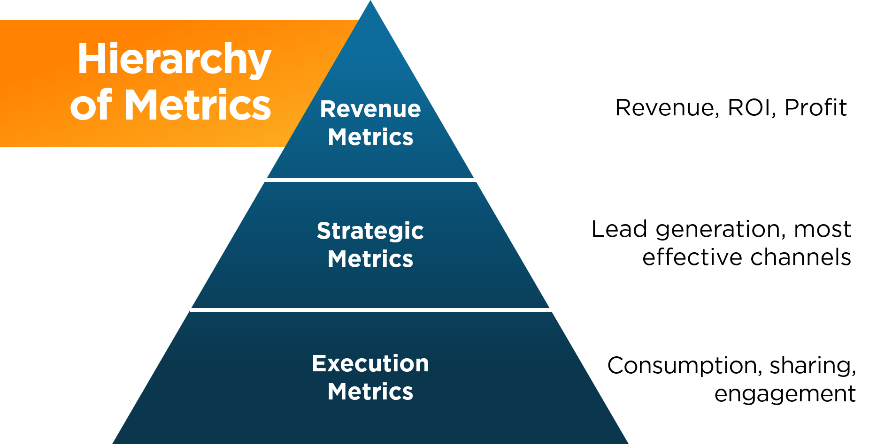

Choosing the Right Metrics
- Which metrics will indicate whether or not you’ve successfully achieved your goal?
- Look at the tactics you’re using to achieve that goal; how will you measure whether you’re performing those activities well? (Execution metrics)
- Look at your overall strategies for that goal; what will you measure to determine if one strategy is more effective than another? (Strategic metrics)
- How are your marketing efforts impacting the bottom line for your business? (Revenue metrics)
- What tools/resources do you need to track these metrics?
- How often will you measure and report on these metrics?

One-Page Marketing Plan Summary

(In a few sentences, summarize your responses to each of the following questions)

What is your Mission Statement and Unique Selling Proposition (USP)?

What does your current business universe look like?

What are your goals?

Who are your ideal customers?

What marketing mix will you use to accomplish your goals?

What is your budget?

How will you measure success?

